**Topic 3**

**Set Path to the Your Project**

In this topic we will learn about:

* How to determine the problem you are addressing
* Writing the problem statement
* Defining the project aims and objective
* Writing the project objectives
* Scoping your project
* Planning for your project

**What is a problem in research/ project?**

At this point, you already have an idea of a project that you intend to do.

What makes you choose the project? What makes you want to take-up the project? Why do you think your supervisor asked you to do the project? The answer is: TO SOLVE A PROBLEM

Most research and project begins because of a problem. Research or project is a process that consist of series of activities that will lead to solving a problem. The problem is the reason doing the project.

**What is a problem statement?**

A problem statement is the description of an issue currently existing which needs to be addressed. It provides the context for the project and generates the objectives which the project aims to solve. The statement of the problem is the focal point of any project. A good problem statement is just one sentence (with several paragraphs of elaboration). In other word, a problem statement expresses the words that will be used to keep the effort focused and it should represent a problem that can be solved. The problem statement is more specific than a topic and it limits the scope of the problem.

The key components of a problem statement:

1. The problem itself, stated clearly and with enough contextual detail to establish why it is important;
2. The method of solving the problem;
3. The purpose, statement of objective and scope of the project being proposed

The problem statement provide context for the research study.

The problem statement should be written clearly, and precisely. It is the first section that people will read in a proposal or a research report. The problem statement will also becomes the source for the project title.

A good problem statement is a result of a thorough study of the problem background.

A good problem statement should be supported. Two ways to support the problem statement:

1. The primary source – when the researcher seek for proof of existence of the problem themselves through the various data collection methods such as questionnaires, observation etc.
2. The secondary source – when the researcher seek for proof of existence of the problem through literature review or work of others.

**Example of a Problem Statement (Adapted from Dr Elin’s (UiTM Jasin) CSP600 notes)**

“Many children have difficulties in learning Mathematical subjects and they are not motivated to study Mathematics (Sedighian, 1996). They find it difficult to learn, boring and irrelevant to their life. Mathematics helps the student with uniquely powerful ways to describe, analyze and change the world. Students are capable to think independently in applied and abstract ways, can give reason, solve problems and assess risk (Arnold, 2003). Since Mathematics play an important roles in our life, the researchers are trying to find ways to attract student’s attention and interest in learning Mathematics with the development of Mathematical games (Swan, 2005, Malone, 2005). However, according to Noor Azli et. Al (2008), the content of existing educational games is irrelevant to the curriculum, the accurate and appropriateness of the content with the game. Therefore, in this research the iCount interactive game is proposed and developed in order to investigate the motivation elements through the understanding of Mathematical concepts.”

•“Many children have difficulties in learning Mathematical subjects and they are not motivated to study Mathematics (Sedighian, 1996). They find it difficult to learn, boring and irrelevant to their life…” – **STATE THE PROBLEM BACKGROUND IN GENERAL**

• “Mathematics helps the student with uniquely powerful ways to describe, analyze and change the world” – **RESEARCHER’S OWN ASSUMPTIONS BUT IT IS SUPPORTED BY LITERATURE EVIDENCE –** “Students are capable to think independently in applied and abstract ways, can give reason, solve problems and assess risk (Arnold, 2003)”.

•“Since Mathematics play an important roles in our life, the researchers are trying to find ways to attract student’s attention and interest in learning Mathematics with the development of Mathematical games (Swan, 2005, Malone, 2005)”. **THE RESEARCHER IS STATING THE REASON WHY THERE IS A NEED TO STUDY THIS TOPIC AND THE IMPORTANCE OF IT AND SUPPORTED BY LITERATURE EVIDENCE.**

•“However, according to Noor Azli et. Al (2008), the content of existing educational games is irrelevant to the curriculum, the accurate and appropriateness of the content with the game” – **STATING THE EXISTING/CURRENT PRACTICE OR CONDITIONS OF THE PROBLEM**

•“Therefore, in this research the iCount interactive game is proposed and developed in order to investigate the motivation elements through the understanding of Mathematical concepts..” **- THE RESEARCHER IS SUGGESTING ON THE PROPOSED SOLUTIONS TOGETHER WITH THE OVERALL RESEARCH AIM**

|  |  |  |  |
| --- | --- | --- | --- |
| State the problem | Who supports the statement | Describe the possible solution | The scope (if required) |
|  |  |  |  |

Table 3.1. A guide to write a problem statement

Example (based on the earlier problem statement):

|  |  |  |  |
| --- | --- | --- | --- |
| State the problem | Who supports the statement | Describe the possible solution | The scope (if required) |
| *Learning mathematic is boring* | * *Many children have difficulties in learning Mathematical subjects and they are not motivated to study Mathematics (Sedighian, 1996).* * *Students are capable to think independently in applied and abstract ways, can give reason, solve problems and assess risk (Arnold, 2003).* * *the content of existing educational games is irrelevant to the curriculum, the accurate and appropriateness of the content with the game”* (*Noor Azli et. al, 2008),* – | * *interactive game to investigate the motivation elements through the understanding of Mathematical concepts* | *Mathematical concepts* |

Table 3.2. A guide to fill in the table



*Tips: Having more than one citations to support is better compared to only having one.

*Tips: You can use either primary or secondary source or both to support your problem.



Once you are able to complete the table, begin rewriting the problem statement in your own words, citing and quoting the literature or your other source(s) of supports.

Now that you are clear about the problem that you are handling, let’s focus on the solution. The AIM for the research.

**Aims of the project**

A *research proposal’s aims* are statements that broadly point out what you hope to accomplish; the desired outcomes from the research. It is the goal that you hope to achieve from your project.

Example of aims:

* To develop and evaluate a courseware to assist in language learning
* To determine the most suitable game genre in delivery the story content as opposed to game playing
* To study the effect of lighting in 3D modelling
* To develop and evaluate the augmented reality application to design the interior of a living room
* To develop an interactive comic as a tool for teaching and learning process
* To model a 3D model for makhraj of Arabic word

Aims will provide an unerstanding of the project’s main purpose.

**Objective**

Objectives lay out how you plan to accomplish your aims.

Aims are broad, objectives are focused and practical. They include a list of practical steps and tasks you're going to take to meet your aims. Objectives are typically numbered, so each one stands alone. Each objective must have a concrete method set out.

The formulation of objectives will help you to:

* Focus the study (narrowing it down to essentials);
* Avoid the collection of data which are not necessary for the problem you have identified;
* Organize the study in clearly defined parts or phases.

Properly formulated objectives will facilitate the development of your research methodology and will help to strategize the data collection, analysis, interpretation and utilization of data.

Figure 3.1. The relationship between aims and objectives

The aim of a research project is to solve a problem. The objcetives are the steps/ activities planned in order to solve the problem. Therefore the objectives must be related to the problem.

Example:

*Project’s Aim:*

*To develop an application to recognize the Arabic character in a Quranic verses.*

*Project’s objectives:*

1. *To do a data collection of Quranic verses.*
2. *To perform segmentation on the images.*
3. *To develop an application to recognize the Arabic character.*
4. *To evaluate the accuracy of the application.*

The objectives must be in a chronological order to the task that has to be done.

**Guide to write the objective**

A guide to write the objective can be based on the *SMART* technique (Dawson, 20015).

* ***S***pecific
* ***M***easurable
* ***A***ppropriate/ Achievable/ Attainable
* ***R***ealistic
* ***T***ime-related

Specific – it gives sufficient idea of what should be done. Very clear.

Measurable – The task that you set in the objectives can be measured for its completeness. Use a measurable verb (can be obtained from Bloom’s Taxonomy; available online)

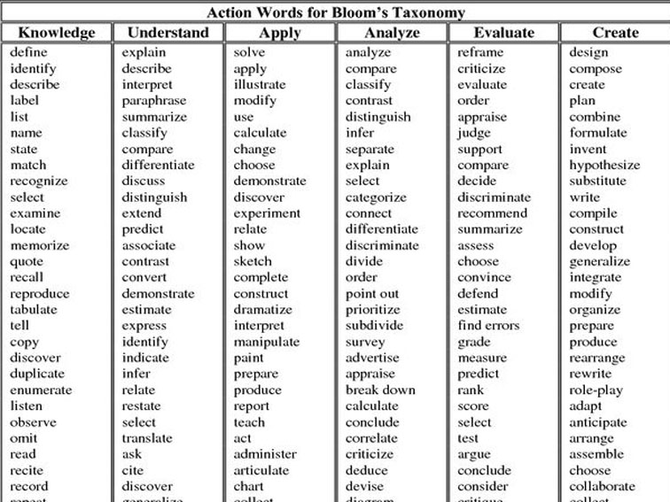

Figure 3.2. Example of measurable verbs that can be used based on the Bloom’s Taxonomy. (http://www.teachthought.com/critical-thinking/blooms-taxonomy/249-blooms-taxonomy-verbs-for-critical-thinking/)

Appropriate/ Achievable/ Attainable – whether the objective is appropriate for the project goal. Whether it is achivable or attainable

Realistic – does the task realistically can be completed within the time frame

Time-related – whether each of the task sufficient for the time that we have. This can be decided when performing the project planning.

**Project Scope**

The scope of the study is defined in terms of temporal (e.g. time, chronology), geographical, sampling and technological coverage, and the level of sophistication of the study in relation to its goal.

Scope determines:

* What are the boundaries/limits?
* Inner boundaries – what should be included IN the project?
* Outer boundaries – what will NOT be in the project?



*Tips: Scope will determine the difficulty of the project too

**Significance of the research**

Literally, significant means something that is sufficiently great or important to be worthy of attention; noteworthy.

From the research point of view, significant is the:

* Importance of the research project.
  + What is the importance ?
  + Why it is important ?
* Usefulness of the research project.
  + What is the usefulness of the research?
  + Why it is useful?
* Benefit of the research project.
  + What is/are the benefit (s)?
  + Who benefits from the project?

With these, you are ready to write Chapter 1 of your research proposal. Chapter 1 is the INTRODUCTION. It consists the following:

* Project Background
* Problem statement
* Project objectives
* Significant of the study
* Conclusion



*Begin writing your Chapter 1: INTRODUCTION and ready for submission in one week time.

**Project Planning**

Merriam-webster definition:

* decide on and arrange in advance.

Planning is a very important task in any research or project development. It will help you set the completion time of each task; the scope of your project.

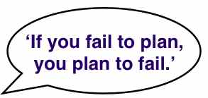

What do you plan in a research project?

According to Dawson (2005):

1. work breakdown
2. time estimates
3. milestone identification
4. activity sequencing
5. scheduling
6. replanning

work breakdown – the detail breakdown of the task that needs to be done to achieve each of the objectives. The detail breakdown can be determined during the research methodology. At this point, the work breakdown can be based on the objectives.

Time estimates – estimates the duration of the research project; estimates the duration of for each individual task.

Milestone identification – to determine the expected completion time for each task in the project. It enables you to assess how your project is progressing. Whether the project progressing as planned/ scheduled.

Activity sequencing – understand what jobs should comes first before the other

Scheduling – put everything you have planned earlier in a diagrammatical form. Schedule your task based on the sequence identified earlier, and the time estimated.

The scheduling of the tasks can be shown in a diagram of a Ghantt Chart and milestone.

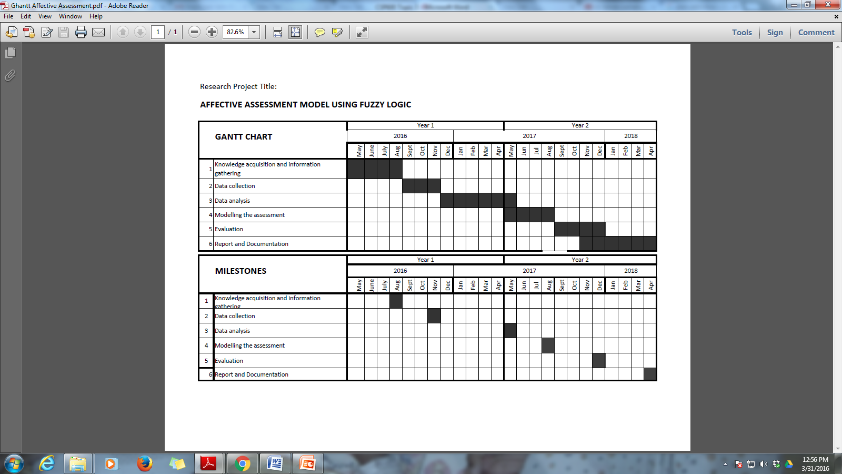

Figure 3.3. Example of a diagram for Ghantt Chart and Milestone

***************************************************